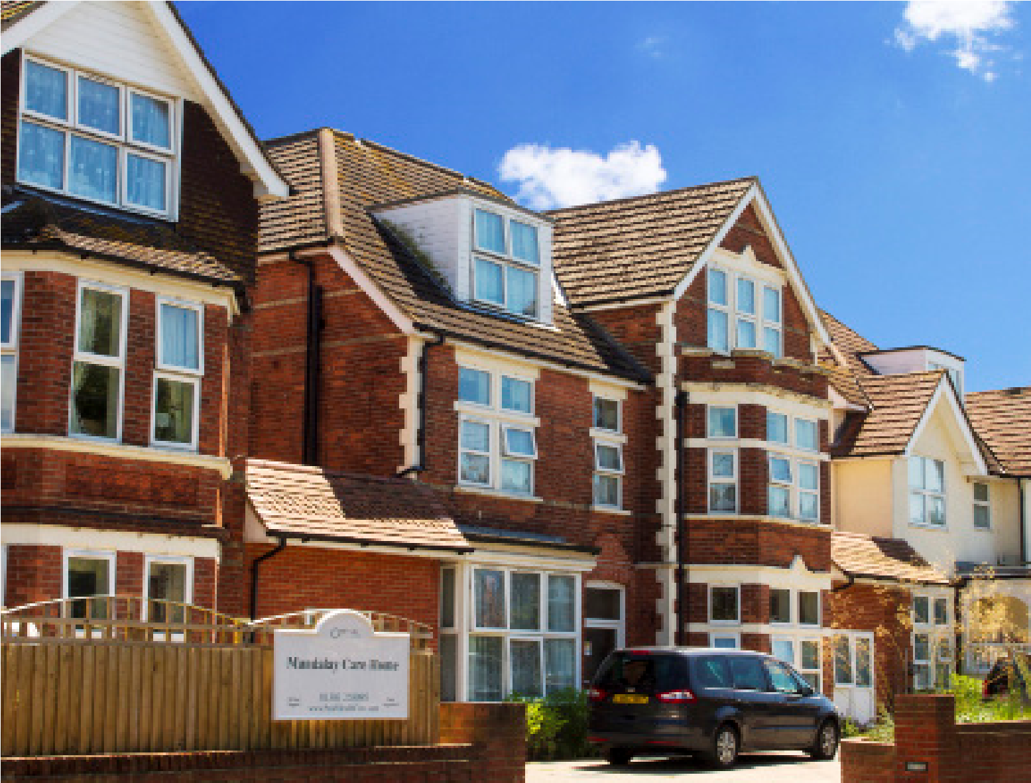
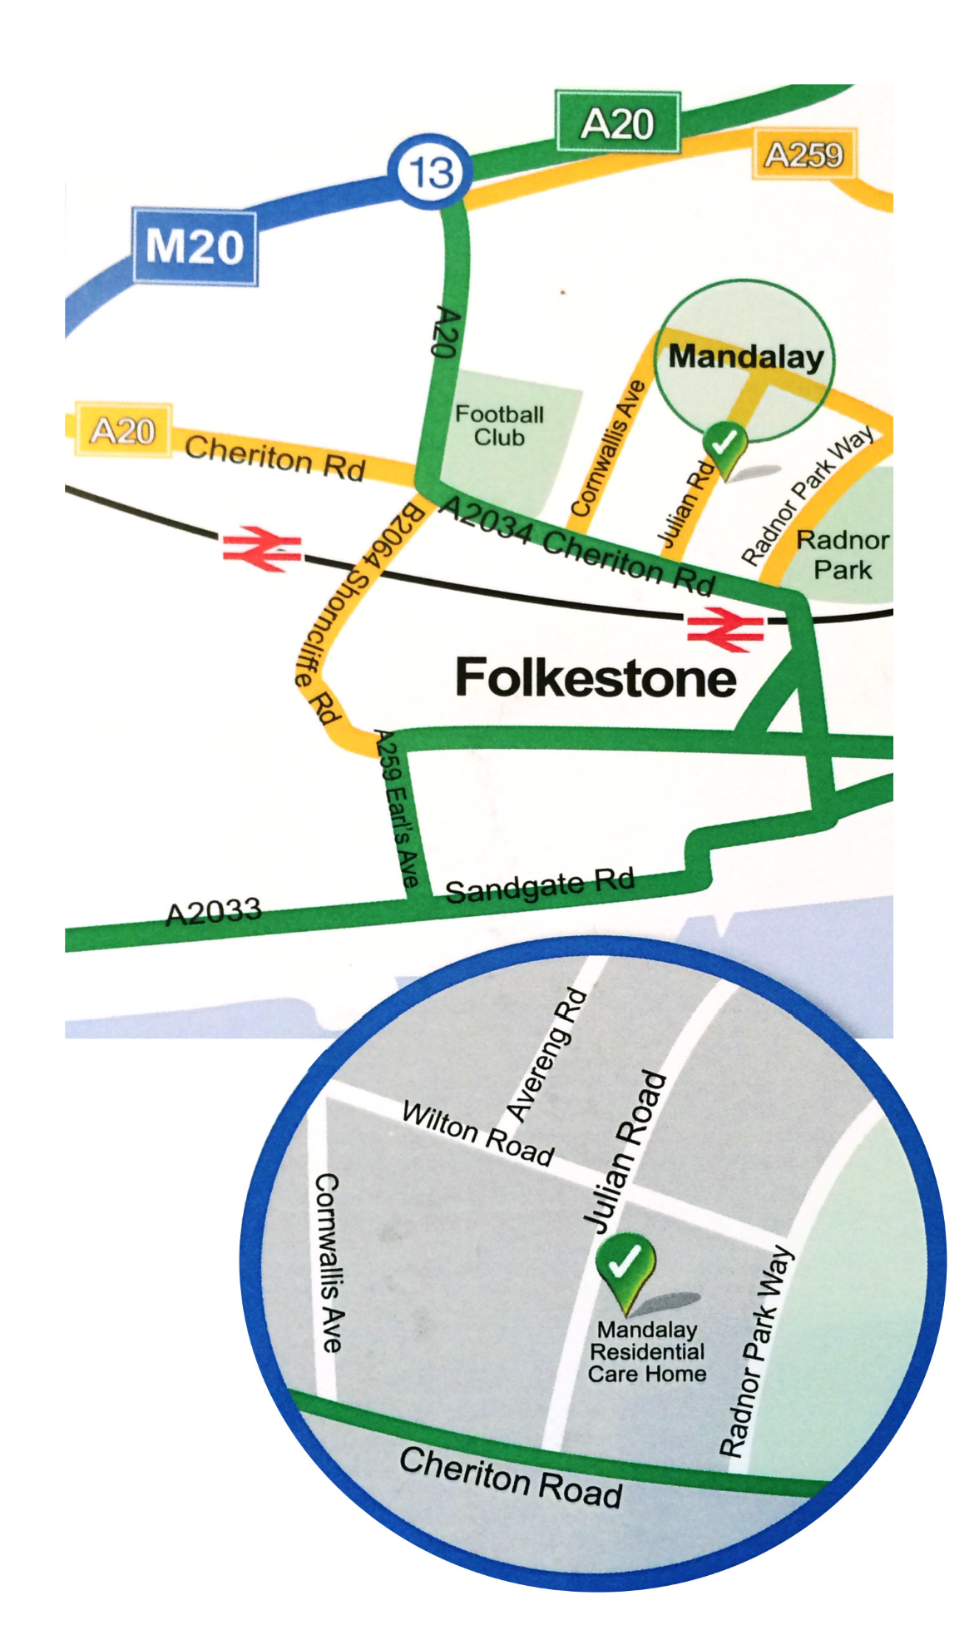

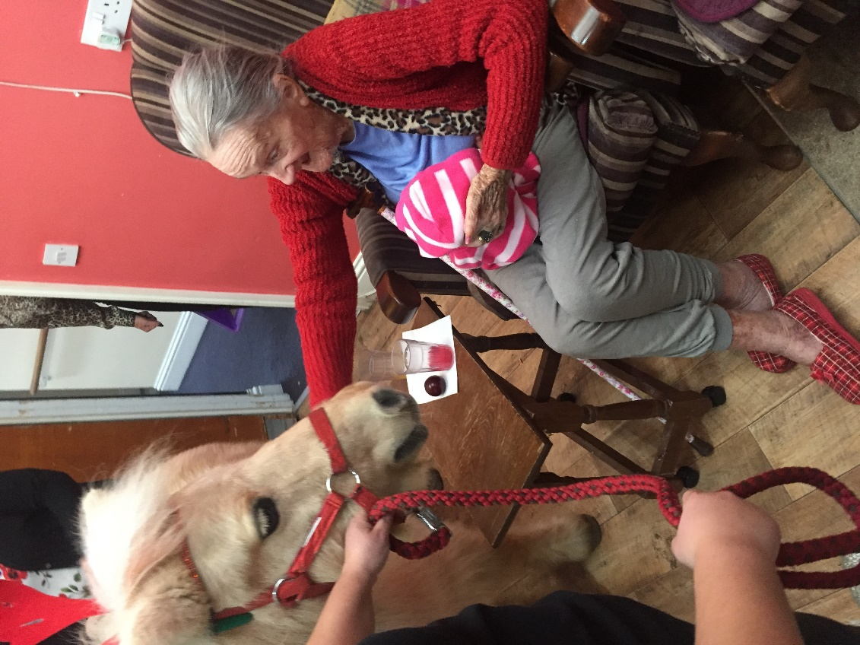
Mandalay
Residential Car
e Home
Folkestone
Individual Care
We recognise that everyone is different and
the care we deliver reflects this. We aim to
create a secure, relaxed, happy and homely
atmosphere for our residents and staff.
Peace of Mind
We are committed to providing the highest
standards of care and service to our residents
and this is achieved through the skills and
determination of our staff.
Mandalay
Residential care home
Call 01303 258095 for further assistance
10-14
Julian Road, Folkestone, CT19 5HP

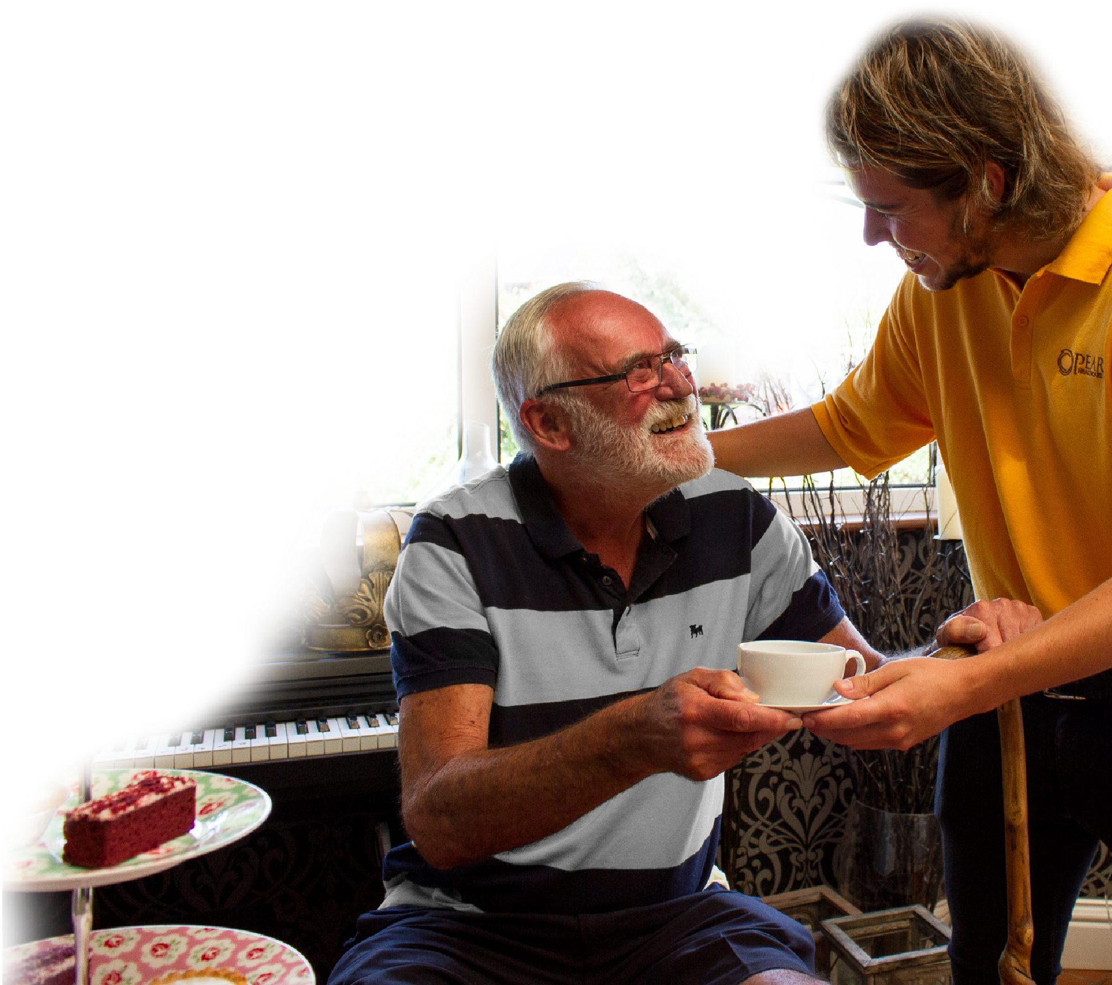

Location
Mandalay is situated in a tree-lined residential
road in the seaside town of Folkestone in Kent.
The home is within walking distance of the
town centre which is well served by a range of
high street shops and has its own theatre.
The Kent coastal region is rich with places
of historical and cultural interest, all within

easy reach of Mandalay, including Norman
churches, the Battle of Britain Museum and
Dover castle. The beautiful and historic city of
Canterbury with its centuries old cathedral is
just 18 miles away.
Comfort & Wellbeing
Mandalay has 45 en-suite rooms, all well-furnished
and equipped with TV & aerial points.
For your peace of mind there is a call system
in every room for residents to seek assistance
should they need it.
Residents are encouraged to bring with them
small items of furniture, pictures and ornaments to
personalise their rooms and help them feel more
at home.
In addition to the comfortable lounge we have a
bright dining room which looks out over a large
garden. The garden and courtyard areas are
wheelchair accessible.
Warm & Welcoming
We have an open visiting policy and visiting friends
and relatives are always made welcome. Visitors
are also welcome to stay for lunch or supper by
arrangement, should they wish.
Activities
Enjoy tailored activities such as gardening,
exercise, board games and quiz nights as well

as specialist activities like reminiscence and music
therapy. Outings include trips to garden centres,
the theatre and Christmas shopping trips.
Residents are the focal point of our service
provision. We ensure that they are fully
involved in the planning and delivery
of services, promoting their right
to dignity, privacy, choice and
independence.
Dementia Care
as
promoting
support
the
Round
clock
in
a
independence
possible

as
much

safe and comfortable environment. Using tailored
care plans and a person centered approach
we get to know our residents individual likes,

dis-likes and habits.
In addition to the home’s dedicated team of staff,
residents can access a range of healthcare and
wellbeing services who will
visit the home, including
GP, district nurses,
chiropodist and
hairdresser.

